Unit Group Project 5 – Code Explanation

Antz Claveus, Ethan Carter, Oscar Garcia, and Thomas Lilchin
Department of Engineering and Technology, Miami Dade
COP 2800: Java Programming
Dr. Martins Idahosa
April 26, 2026

Welcome to our final group project! In this project, we utilized the Swing architecture that is a part of the Java JDK to create our own GUI application. In this code explanation, we would like to go over what are struggles and overall experiences were with this project.
First off, when it came building a GUI, it shifted our understanding of input and output. We take for granted the work that goes behind creating a GUI application that, with doing this assignment, a proverbial ‘veil’ is taken off of our eyes. We now understand the work that goes into creating a GUI and that every button has a label and an ActionListener behind it.
Honestly, the most challenging part of wiring up event listeners was creating separate methods to not have all of the code an event listener takes into one set of brackets.
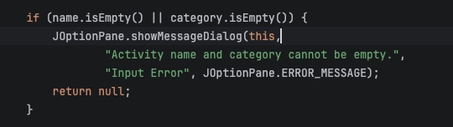
When it came to input validation, we utilized it in our createActivityFromInput method, among other places. The way input was validated was very similar to that of the console version – just now, it is assigned to an ActionListener method.
In regard to reusing classes or methods from earlier parts, we did not reuse anything. Everything is unique to this project.
In choosing the components of our project, they were provided to us. However, if we were to say why they were chosen, it leads to the functionality of this GUI program. This program, receives 4 text inputs, 2 buttons, and 1 output field. These input fields were needed to receive the user’s data, the 2 buttons to process the information, and 1 output field to display the processed data output.
In regard to the layouts we chose, we used GridLayout as it allows us to have order to our fields – and we used FlowLayout for our buttons as it allows us to center the buttons and have them in areas of the same size.
In our opinion, we would not change anything about the interface as it was pretty simply to implement – other than the complexity of Swing code.
In having a good activity hierarchy, we saw that would could organize, first, the activity fields, then, the buttons, and then the output field. Everything flows from top to bottom, perfectly.
When it came to debugging issues that only appeared when clicking buttons, we didn’t really have many debugging situations.
Alright! This GUI can definitely be extended to support saving/loading data. Not sure how, code-wise, we would be able to make it happen, but, this is how we would do it – we would implement two more buttons: one for saving and the other for loading data. With these new buttons created, we would create ActionListeners that save or fetch the data that was previously saved.
The foundation of Swing, in our opinion, is understanding each different thing that you can do and must do in Swing. For example, known that JFrame and JPanels are needed as well as which types of layouts you need to organize the buttons and fields within the GUI program. Additionally, having a firm understanding of how to add functionality to buttons and different fields is vital to Swing programming as, without it, you would just have a pretty application that does absolutely nothing.
Finally, we would like to thank our Professor, Dr. Martins Idahosa for a great semester. May God bless him and his family!

